REPUBLIC OF TURKIYE
KAYSERİ METROPOLITAN MUNICIPALITY
CLIMATE AND DISASTER RESILIENT CITIES PROJECT
(CDRCP)
TERMS OF REFERENCE
Consultancy Services for Construction Supervision Services for Kartal Junction and Connection Roads Construction Project

Introduction and Background
The Climate and Disaster Resilient Cities Project aims to increase access to seismic and climate resilient housing, municipal infrastructure and services in Project Provinces in Türkiye, and to respond promptly and effectively in the event of an Eligible Crisis or Emergency. It will support the government in tackling the challenges related to climate and disaster resilient housing and infrastructure interventions in the urban areas of selected provinces in Türkiye.
The Project will be implemented through five components, namely (1) Institutional strengthening to enable conditions for urban resilience, (2) Expanding access to resilient housing, (3) Investments in climate and disaster resilient municipal infrastructure, (4a,4b) Project Management, Monitoring, and Evaluation and (5) Contingent Emergency Response Component (CERC).
Components 1, 2, 4a and 5 are being implemented by the Urban Transformation Presidency (UTP) affiliated with the Ministry of Environment, Urbanization and Climate Change (MoEUCC). This part of the Project will provide sub-loans to eligible owners to retrofit or reconstruct their housing or commercial units in risky buildings in the provinces of Izmir, Istanbul, Kahramanmaras, Manisa and Tekirdag, complemented by technical assistance to UTP/MoEUCC and local authorities to strengthen their capacity to develop, implement, and monitor green and resilient urban transformation programs.
Component 3 will support ILBANK to on-lend loans (in Euro) with longer maturities and lower interest rates than the comparable domestic market to the Project metropolitan municipalities and affiliated water and sanitation utilities in the provinces of Izmir, Istanbul, Manisa, Sakarya, and Kayseri (municipal sub-borrowers) to undertake municipal infrastructure investments that increase resilience against the impacts of climate-related and/or other disaster hazards. ILBANK will be the Financial Intermediary (FI) for this Component, and the municipal sub-borrowers will be responsible for implementation of their eligible subprojects. ILBANK will ensure the financial viability and creditworthiness of the sub-borrowers per standard practice. The Component will finance works, goods, non-consulting, and consultant services for: (i) demand-driven resilient and green municipal infrastructure investments in the eligible provinces, including the construction or rehabilitation of stormwater, drainage, and flood management systems, water and wastewater systems and treatment plants, and urban transport systems; and (ii) technical assistance to municipal sub-borrowers to strengthen management and implementation support (e.g., procurement, environmental and social management, citizen engagement) for climate and disaster resilient municipal subprojects.
Component 4b will finance the provision of goods, consulting services, non-consulting services, and operating costs to ILBANK for management and supervision of the Project in compliance with World Bank regulations and standards, including but not limited to monitoring and evaluation, reporting, procurement, financial management, disbursement, environmental and social management, grievance redress mechanisms, as well as communication and outreach activities.

Project Description
The overall objective of the Project is to increase access to seismic and climate resilient housing, municipal infrastructure and services in Project provinces in Türkiye and to respond promptly and effectively in the event of an Eligible Crisis or Emergency.

Institutional Roles:
ILBANK as a financial institution provides financial and technical support for many projects in line with its sustainability goals, in order to improve water and wastewater services, cost-effective and accessible public transportation, sustainable, safe, and environmental solid waste management, reduce greenhouse gas emissions, build resilience against disasters and climate effects through investments in municipalities, improve the environment and reduce pollution in municipalities, develop institutional capacity at the municipal level for sustainable development investments and increase efficiency.
ILBANK is the main borrower of the Project and acts as the Financial Intermediary (FI) to allocate a part of the Loan to Kayseri Metropolitan Municipality for financing resilient urban transport infrastructure investments (Subproject). ILBANK is responsible for monitoring the implementation of the Subproject activities, including overseeing the execution of these activities and ensuring the achievement of desired results.
ILBANK ensures that the project complies with the World Bank's environmental and social standards, as well as procurement regulations. ILBANK will provide additional support for procurement, implementation, and supervision to the municipalities. The World Bank, as the financier, will provide regular supervision and implementation support to ILBANK, as stipulated in the Loan Agreement.
Kayseri Metropolitan Municipality is the contracting authority (the ‘Client’) responsible for procuring the works from a contractor (‘Contractor’), as well as consultancy services for supervision from a consulting firm (the ‘Consultant’). The consulting services are the subject of this Terms of Reference and the assignment in question.
Kayseri Metropolitan Municipality shall establish a project implementation unit (PIU) at local level to ensure effective project implementation.

Objectives of the Assignment
The objective of the assignment is (i) construction supervision services, and (ii) supervision of the remedial works to rectify defects that arise during the Defects Liability Period (DLP) for the Kartal Junction and Connection Roads Construction Sub-Project construction works listed below.
There will be 1 (one) construction contract as follows:
- Kartal Junction and Connection Roads Construction Sub-Project
Further details of the Scope of Services shall be outlined in the next Sections of this Terms of Reference.

Subproject Descriptions:
The Consultant shall be responsible for the Kayseri Metropolitan Municipality Kartal Junction and Connection Roads Construction Sub-Project. Kartal Junction and Connection Roads Construction Sub-Project aims to enhance Kayseri’s urban mobility resilience during disasters and emergencies by ensuring uninterrupted traffic flow at the intersections along designated emergency response routes. The primary objectives include the establishment of vital escape corridors during disasters and emergencies and the development of urban infrastructure to be resilient against disasters within the framework of the Kayseri Provincial Disaster Risk Reduction Plan (İRAP). Concordantly, Mustafa Kemal Pasa Boulevard, Talas Boulevard, Seyyid Burhanettin Boulevard, Mehmet Ozhaseki Boulevard and Şehit Tarık Kocoglu Boulevard, located in the Melikgazi district of Kayseri, have been designated as emergency response routes in line with the "Emergency Action Plan" under the "Disaster-Resilient Cities" initiative. The Kartal Intersection and the connected intersections (K-1, K-2, K-3), located at these routes, constitute critical nodes within the urban transportation network.

Project alignment: The project route is approximately 1290 meters. There are three underpasses and two tunnel structures in the area.

Intersections: There are three intersections in the project area, named K1, K2, and K3. There are 1 underpass and 1 tunnel at the K1 Junction. There are 1 underpass and 1 tunnel at the K2 Junction. There is 1 underpass at the K3 Junction.

Tunnels: There are two tunnels planned to be constructed using the closed excavation (cut and cover) method.
These tunnels have cast-in-situ reinforced concrete slabs on reinforced concrete piles.

Underpasses: At the K1 intersection, there is an underpass approximately 23 meters wide and 80 meters long. This underpass has approach distances of 160 and 190 meters. At the K2 intersection, there is an underpass approximately 21 meters wide and 50 meters long. This underpass has approach distances of 140 and 160 meters. These underpasses have cast-in-situ reinforced concrete slabs on reinforced concrete piles.

Other engineering structures: There are reinforced concrete retaining walls around the entrances of the underpasses and tunnels.

There is a 1.29 km2 national garden at the south of the intersections, that is a first-degree gathering area in disaster and emergency scenarios and can serve 517,500 people and is an urban recreation area. The main transportation axes surrounding the project area are presented below (Figure 1.1 and 1.2).
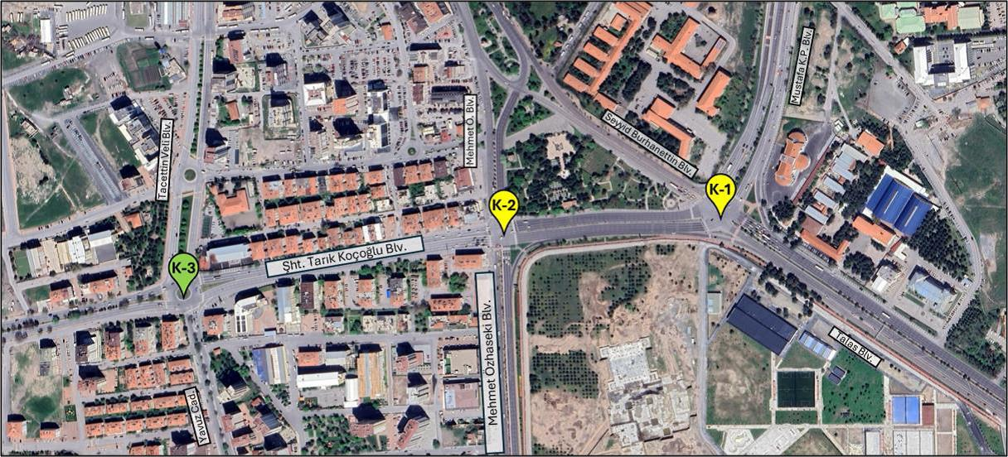
Figure-1.1: K1, K2 and K3 Intersection in current situation.
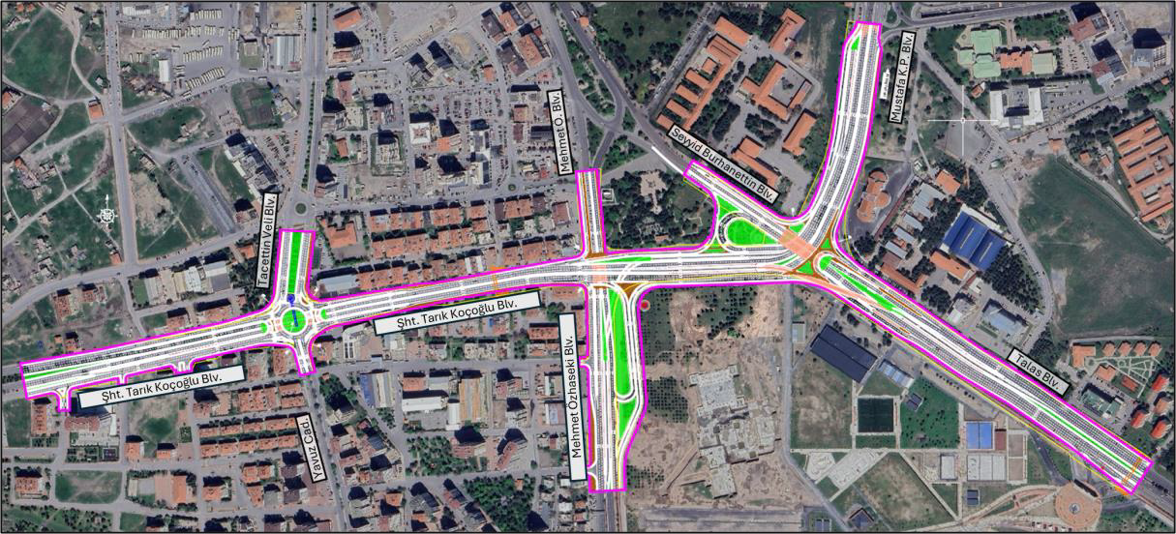
Figure-1.2: K1 Underpass, Tunnel, Pedestrian Underpass, K2 Underpass, Tunnel, Pedestrian Underpass and K3 Underpass plotted on a map.

Subproject Area:
The scope of this Contract covers certain investments in Kayseri Province as detailed in the further Sections of this Terms of Reference. The following figures shows Kayseri Province as the subject of this Terms of Reference.
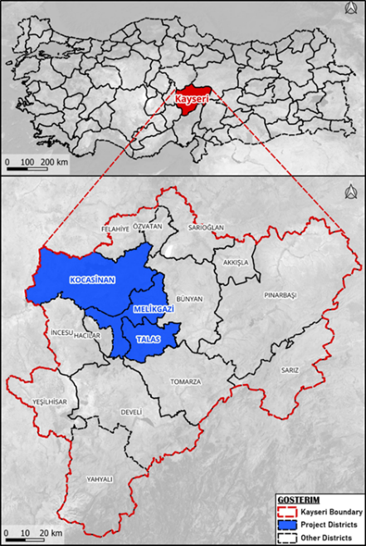
Figur- 2: Kayseri Province and its Districts

Table 1. Climate Data of Kayseri Province
Kayseri climate
Months | January | February | March | April | May | June | July | August | September | October | November | December | year
Highest temperature (°C) | 19,3 | 22,6 | 28,6 | 31,2 | 33,6 | 36,8 | 40,7 | 40,6 | 36,0 | 33,6 | 25,6 | 21,0 | 40,7
Average maximum temperature (°C) | 4,2 | 6,2 | 11,6 | 17,8 | 22,4 | 26,7 | 30,6 | 30,8 | 26,7 | 20,3 | 12,8 | 6,4 | 18,0
Average temperature (°C) | −1,6 | 0,1 | 5,0 | 10,8 | 15,1 | 19,2 | 22,7 | 22,2 | 17,4 | 11,6 | 5,1 | 0,4 | 10,6
Average lowest temperature (°C) | −6,8 | −5,3 | −1,3 | 3,3 | 6,7 | 9,7 | 11,9 | 11,4 | 7,3 | 3,5 | −1,1 | −4,6 | 2,8
Lowest temperature (°C) | −32,5 | −31,2 | −28,1 | −11,6 | −6,9 | −0,6 | 2,9 | 1,4 | −3,8 | −12,2 | −20,7 | −28,4 | −32,5
Average precipitation (mm) | 33,7 | 36,5 | 42,7 | 52,4 | 52,4 | 40,9 | 10,0 | 5,9 | 13,7 | 28,4 | 33,2 | 38,8 | 388,6
General Directorate of Meteorology.

The impact of the two earthquakes occurred in Kahramanmaraş on February 6, 2023, which a magnitude of 7.7 centered in Pazarcık and a magnitude of 7.6 centered in Elbistan, was examined to assess the province's response during past disasters and emergencies. Following the Kahramanmaraş Earthquake, numerous aftershocks, the largest being 6.6 in magnitude, were recorded and felt intensely in the surrounding provinces. The revised AFAD-RED (AFAD - Earthquake Rapid Damage and Loss Estimation System) estimated intensity map of the Pazarcık earthquake with a magnitude of Mw: 7.7 showed that it was felt in Kayseri as a magnitude V (moderate) (4.5 Richter Magnitude) and the revised AFAD-RED estimated intensity map of the Elbistan earthquake with a magnitude of Mw: 7.6 showed that it was felt in Kayseri as a magnitude V (moderate) - VI (strong) (4.5 - 5.1 Richter Magnitude). Additionally, traffic on the city's main arteries— Sht. Tarık Kocoglu Boulevard, Talas Boulevard, and Mustafa Kemal Pasa Boulevard—was paralyzed and remained non-operational for several hours.

This situation has subsequently led to questioning the capacity of the existing transportation infrastructure in the city center to respond to post-disaster needs. This experience highlighted the critical necessity of ensuring the functionality of emergency response routes, particularly during and after a disaster. Kartal Intersection and its connected intersections have a strategic role in urban transportation due to providing access to the National Garden, which is an urban assembly area, and being located on emergency response routes.

Since the Kartal Intersection and related intersections are on boulevards designated as emergency response routes and provide access to the National Garden, which is an urban gathering area, it is expected that traffic density, along with congestion at intersections, will increase during disasters and emergencies. Therefore, Kartal Junction and Connection Roads Construction Sub-Project focuses on planning pedestrian and vehicular traffic at the Kartal Intersection and its connected intersections (K-1, K-2, K-3) to ensure ease of access, preparedness for disaster and emergency scenarios, and to make them resistant to disasters and climate.

The Kartal Intersection and the connected intersections serve as signalized and at-grade in the case of no project. The intersections work in coordination, and the cycle time is 110 seconds. The satellite image of the K1-K2-K3 intersections is provided below (Figure 3).

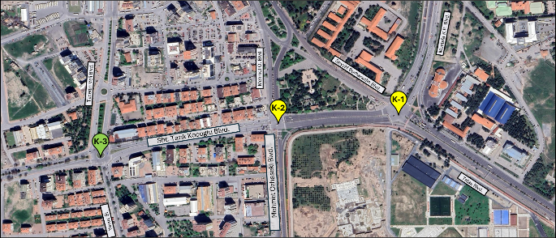
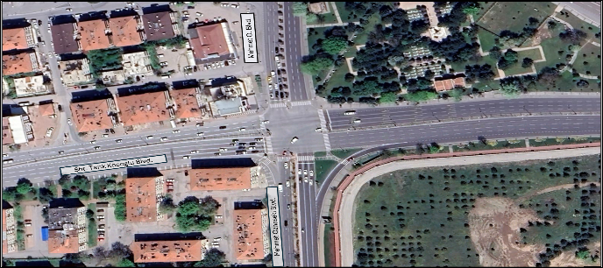
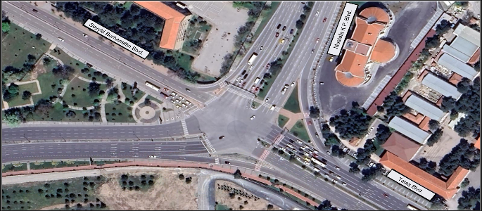
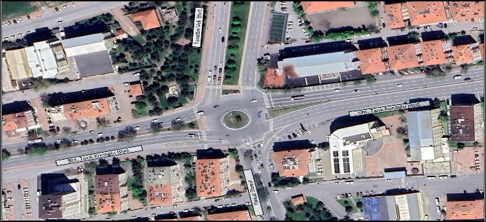

Figure-3: Kartal Junction and Connection Roads Construction Sub-Project

Information/Data to be provided to the Consultant:
The above-mentioned sub-project has its own Project Information Document (PID) and have full set of drawings. PID, existing designs, drawings, Environmental and Social Impact Assessment (ESIA) and/or Environmental and Social Management Plan (ESMP), Stakeholder Engagement Plan (SEP), Resettlement Plans (RPs), (where relevant) and CWS documents will be provided to the Consultant as part of the Request for Proposals in electronic format.
As a part of the Environmental and Social Assessment (ESA), ESIA and/or ESMP, SEP, RP (any expropriation occur) and Ex-post Social Audit (EPSA) (lands expropriated within the past 5 years) of these subprojects are being prepared according to project specifications in full compliance with the ILBANK ESMS which aligns with the WB’s ESF and its Standards. The Environmental and Social Due Diligence (ESDD) for the subproject has been finalized and Environmental and Social Action Plan (ESAP) has been completed based on ESDD by ILBANK. The Client as sub-borrower has to commit to ESAP and other Environmental and Social requirements as per ESA deliverables to implemented, monitored and reported throughout sub-loan duration (including construction and operation phases of the subproject) in accordance with ILBANK ESMS. If any land acquisition related issues and needs emerge within the scope of the subproject during implementation, the Client and the Supervision Consultant are responsible for informing ILBANK immediately. The Supervision Consultant will clearly identify these and will provide support to the Client for the preparation of the RP/EPSA (if/where relevant). The Supervision Consultant should ensure that the Client take necessary actions such as preparation or updating of RP or EPSA. Moreover, Labor Management Procedures (LMP) (including Code of Conduct) for the project is prepared by ILBANK to be implemented by the awarded contractors/their subcontractors. The contractor will be responsible for the preparation of their own Labor Management Plan based on the Labor Management Procedures.

Scope of the Services:
The Scope of Services of the Consultant under this Contract is as follows:
TO PROVIDE SUPERVISION SERVICES DURING THE CONSTRUCTION STAGE AND DEFECTS LIABILITY PERIOD
The Consultant shall be responsible to carry out all the duties and responsibilities attributed to the “Project Manager” or “Engineer” as part of the Contract. The Supervision responsibility of the Consultant shall be for all the Works Contracts signed as a result of the bidding processes concluded under this Contract and shall continue until the expiration of the Defects Liability Period/Warranty Period. The issues requiring Client approval will be clearly outlined and specified in the relevant sections of the General Conditions of Contract (GCC) and Particular Conditions of Contract (PCC) for each respective works contract.
As an addition to these tasks as the Project Manager, the Consultant shall:
- Follow-up and inform the Client about progress of the work and activities, attend any meetings reasonably convened by the Client and provide any information or evidence reasonably required by the Client at any public meetings or inquiries that might be held in connection with the Project.
- Follow-up and inform the Client about the cost and time impact and any other consequences of any sort of his proposals (such as revisions, recommendations, etc.). The Client shall not be responsible for the consequences of the fact of which the Client is not informed in advance.
- In case of an arbitration in the Works Contract/s, to assist the Client in the preparation of the documents needed by the Client.
- As in compliance with the format and content determined by the Client, prepare monthly and quarterly progress reports in comparative with original (initial) work schedules and inform the Client in written for delays in a timely manner.
- Based on the approved work schedule and cash flows of the Contractor/s; monitor the progress compared to the initially envisaged plan/s and inform the Client about the failures in advance and propose mitigation measures to prevent further failures and solve all problems in the sites within the scope of duties assigned with this TOR. The consultant and the contractor’s project manager have the right to take and implement any responsibility in accordance with the legal documentation.
- During all kinds of material approval process: establishment and acceptance of factory and material acceptances, determination and approval of the institutions or organizations (laboratories, universities, etc.) where the tests are to be conducted, approval or rejection of the materials, ensuring the use of approved materials at site and removal of unauthorized materials from the site and monitoring according to Turkish regulations.
- Randomly collect material samples and perform relevant tests and analyzes at specified in Technical Specifications Section of Work Contract in intervals without waiting the written mandate of the Client.
- Keep accurate and detailed site records.
- For construction works, conduct conformity monitoring of Environmental and Social liabilities including Occupational Health and Safety (OHS) issues mentioned in the Environmental and Social Impact Assessment (ESIA) and/or Environmental and Social Management Plan (ESMP) that are prepared according the Environmental and Social Management Framework (ESMF) . All regular reporting obligations mentioned in these documents shall be followed for the construction activities.
- Ensure implementation of ESAP, ESIA and/or ESMP, LMP, RP if prepared for this project Ex-Post Social Audit Reports (if any) and SEPs as required, in a manner acceptable to ILBANK and make sure that no construction activity shall commence before the land acquisition process completed for the privately-owned land and permits/licenses received to use/transfer rights of public lands.
- If any land acquisition related issues and needs emerge within the scope of the subproject during implementation, the Client and the Supervision Consultant are responsible for informing ILBANK immediately. The Supervision Consultant will clearly identify these and will provide support to the Client for the preparation of a RP/EPSA (if/where relevant). The Supervision Consultant should ensure that the Client take necessary actions such as preparation or updating of RP or EPSA.
- Follow up the grievance mechanism mentioned in the Climate and Disaster Resilient Cities Project ESMF, Resettlement Framework (RF) and Stakeholder Engagement Plan (SEP) and also these issues should be included in the prepared progress reports.
The Services will be carried out under the following Parts:
Part 1: Tasks prior to start of construction works will include but not be limited to:
- Review the qualifications of the proposed key management personnel of the Contractor/s and make appropriate recommendations to the Client,
- Ensuring submission of the Quality Assurance (QA) Plan submitted by the Contractor, checking and approving its compliance with the contract requirements,
- Verifying that all necessary permits and licenses from relevant public institutions have been fully obtained.
- Explain and/or adjust ambiguities and/or discrepancies in the Contract Documents in advance in order to avoid any dispute,
- Receive from the Contractor/s, check for compliance with contract requirements and advise the Client on all performance securities, insurance certificates or policies and guarantees relating to the contract before submitting to the Client for acceptance,
- Facilitate communication and attend meetings between the contractor(s) and the owners of facilities (e.g., water, telephone, electricity, gas) sharing the road right-of-way. Specifically, provide advice on proposed modifications from facility owners and assist with on-site handover protocols between the client (administration/municipality) and the contractor,
- Review and approval of mobilization plan,
- Review and approval of construction methodology and material procurement schedule,
- Review and approval of Contractor’s Occupational Health & Safety Plan, Site Risk Assessment and Emergency Preparedness and Response Plan
- Ensuring the submission of site mobilization and layout plans by the Contractor, checking and approving their compliance with the contract requirements,
- Ensuring the submission of method of statements and work schedule by the Contractor, checking and approving their compliance with contract requirements,
- Ensure that Environmental and Social (ES) provisions and OHS provision set out in the contract documents are respected including to check if the necessary E&S capacity (including OHS) is provided by the contractor – e.g. one full time environmental specialist, one full time social specialist, three full time OHS specialists, etc.
- Ensuring submission of all sub-management plans addressed in subproject specific E&S assessment reports including OHS Management plans, traffic management plans, and other required E&S management plans to ILBANK for approval by the Contractor, reviewing, and approving their compliance with the contract requirements before commencing the works,
- Ensuring the submission of material and equipment procurement program submitted by the Contractor, checking and approving their compliance with the contract requirements,
- Check correctness of coordinates and levels of all survey reference markers and require the Contractor/s to make an independent check,
- Check the Contractor/s’ setting out and levels of the designed works,
- Verify estimated quantities in the Bills of Quantities and promptly advise the Client of any prospective Time and Cost effects and make appropriate recommendations,
- Take measures for the proper implementation of ESAP, ESIA and/or ESMP, LMP, and SEP including the grievance mechanism.
- If any land acquisition issues and needs emerge within the scope of the subproject during implementation, the Supervision Consultant will identify these and will provide support to the Client for the preparation of a RP/EPSA (if/where relevant). The Client and the Supervision Consultant are responsible for informing ILBANK immediately if such a case emerges.
- Supervision Consultant may be requested to support the municipalities for the preparation of the RP/EPSA monitoring/progress reports.
- Ensuring RP implementation (if needed/relevant) is completed prior to commencement of any civil works on site.

Part 2: Tasks during construction will include but not be limited to:
2.1 Supervision tasks
- Approve and monitor the Contractor/s’ work program and the source of materials,
- Monitor the implementation of Contractor/s’ Quality Assurance/Quality Control (QA/QC) Plan and revise when necessary,
- Explain and/or adjust ambiguities and/or discrepancies in the Contract Documents in advance in order to avoid any dispute,
- Inspect for approval of all shop drawings and as-built drawings prepared by the Contractor/s,
- Supervise inspection and testing of materials and works to ensure compliance with specifications, designs, and/or removal and substitution of improper materials and/or work as required,
- Ensure the Contractor/s’ compliance with the agreed Environmental and Social Impact Assessment (ESIA) and/or Environmental and Social Management Plan (ESMP); to control and appraise the progress of the works, to order suspension of works and to authorize, with the Client’s approval, extensions of the period for completion of the works; The Consultant shall take necessary measures for environmental, social, and occupational health and safety aspects. In this context the most recent Turkish environmental and safety regulations as well as the Client and WB Environmental and Social Standards and WBG’s General and Sector Specific EHS Guidelines, Environment, Social, Health and Safety (ESHS) policies are required to be taken into consideration particularly during the supervision of the construction works. Within this scope, Consultant shall also be responsible for the supervision of the Contractor/s’ environmental and social management practices/plans (grievance mechanism, stakeholder engagement, waste management, noise, occupational health and safety, resettlement plan,etc.) and ESHS obligations and report to the Client in its monthly and quarterly progress reports. The details of the ESHS Management and the responsibilities of the “Consultant” shall also be detailed in the Contractor/s’ contract. The Consultant shall have the responsibility for relevant supervision, oversight, and instruction of the applications to the Contractor/s.
- Make sure the following flow; in case of a significant work accident, the Contractor will immediately inform the Consultant and the Municipality about the accident. The Municipality and OHS supervisor will be responsible for notifying this accident to İLBANK within 24 hours and İLBANK will be responsible for informing World Bank about the accident within 48 hours after the accident occurred.
- If any land acquisition related issues and needs emerge within the scope of the subproject during implementation, the Client and the Supervision Consultant are responsible for informing ILBANK immediately. The Supervision Consultant will clearly identify these and will provide support to the Client for the preparation of a RP/EPSA (if/where relevant). The Supervision Consultant should ensure that the Client take necessary actions such as preparation or updating of RP or EPSA.
- Provide assistance in administering and resolving grievances, in addition ensuring that grievances are recorded on the grievance forms and grievance closure forms,
- Issue interim certificates for payment to the Contractor/s on the basis of measured work items or to certify the completion of the works or parts thereof,
- Carry out generally all the duties of the Project Manager/Engineer as specified in the Contract, within the limitations specified therein,
- Prepare the variation order documents with own comments and advise the Client on all matters relating to additional works, scope change, variations and claims reported by the Contractor/s and make recommendations thereon. Project manager give the approval for request officially,
- Attend to the work inspections carried out by the State Authorities in accordance with the applicable laws,
- Organize taking over and performance certificate of works and submit all supervision documents to the taking-over committee according to the Contract and Applicable Law.
- Issue the Certificates of Completion of the Works and Defects Liability Certificates,
- Assist the Client in taking over the site of the works,
- The Consultant will assist and provide the necessary technical information about the projects to the Client and ILBANK for their assessing the energy efficiency and Greenhouse Gas (GHG) Emissions and Calculations if requested by the Client and ILBANK.

2.2 Administration of the Civil Works Contracts
The responsibility of the Consultant shall include, but not limited to, the following tasks:
- Financial management of the Civil Works Contracts. Based on (i) the Contractor/s’ program of works and cash-flow predictions which should be revised at required time intervals and, (ii) upon own judgement, the Project Manager shall prepare monthly, as part of monthly reports, disbursement tables showing the status of previous disbursements and a tentative prediction of future disbursements on a monthly basis;
- Monitor validity of the Contractor/s’ insurance policies and guarantees and timely advice the Client on their expiry dates, necessity to request the extensions of the validity and where necessary change the amount of the insurance policies and guarantees;
- Provision and administration of the Project Management Information System (PMIS) for management of project correspondence and documents in accordance with the approved PMIS plan and procedures, and timely updates of the records and reports thereof;
- Continuous follow-up of the Contractor/s work programs and monitoring cash-flow in relation to the planned schedules and alert immediately the Client if any change occurs in the progress of disbursements;
- Day-to-day measurement and recording of quantities of works carried out by Contractor/s;
- Daily recording of work site events in a work site logbook;
- Recapitulation of quantities of work carried out monthly for each contractual item of work;
- Monthly comparison of actual progress against progress as scheduled and take precautions if needed;
- Review Contractor/s’ Monthly Statements and issue the corresponding Payment Certificates as appropriate;
- Attendance at periodic site meetings and monthly progress meetings and ensuring minutes signed by all parties are recorded.
The required procedures to carry out the site supervision and contract administration tasks shall be prepared by the Consultant and submitted for the approval of the Client in a Consultant’s Site Supervision Procedures Manual.
2.3 Administration of Environmental, Social, Health and Safety (ESHS)
The Consultant shall ensure that the Contractor/s’ Environmental and Social (E&S) performance is in accordance with good international industry practice and delivers the Contractor/s’ E&S obligations.
The ES related services include those of the Project Manager’s as referred in the World Bank’s Standard Procurement Document - Request for Bids Small Works (If needed as a result of the cost estimates, the Standard Procurement Document could change). Services to be provided by the Consultant will include but are not limited to the following:
- Review and revision of the Contractor’s Environmental and Social Management Plan (C-ESMP) including all updates and revisions, as well as sub-management plans (if any) (not less than once every 6 months) In addition, the awarded bidder will be provided with ILBANK's templates for monthly, quarterly and semi-annual ESMP monitoring reports, as well as a copy of the Occupational Safety and Health Incident Reporting Tool (ESIRT), in order to prepare the required reports;
- Review and approve ESHS provisions of method statements, implementation plans, drawings, proposals, schedules and all relevant Contractor’s documents;
- Review and revision ESHG provisions of any design change proposals and the implications for compliance with project specific ESIA and/or ESMP/RP(if any)/EPSA (if any)/SEP/GM, consent/permits and other relevant project requirements,
- Undertake audits, supervisions and/or inspections of any sites where the Contractor is undertaking activities related to the Works, in order to ensure and verify the Contractor’s compliance with ESMP requirements, with and without Contractor and/or Client relevant representatives, as necessary;
- Undertake audits and inspections of Contractor’s Occupational Health and Safety (OHS) provisions, OHS logs and safe working environments, construction site and campsite risk assessments, contracts and qualification certificates of OHS unit (OHS experts, workplace physicians, other health staff etc.), work permit records of all environmental and social practices specified in the ESIA and/or ESMP, stakeholder engagement activities carried, community liaison records including all grievances received, managed and resolved (Grievance Logs), monitoring findings and other ESHS related documentation, as necessary, to confirm the Contractor’s compliance with ESIA and/or ESMP requirements.
The duties and responsibilities of the consultant regarding OHS management will include the following:
- Checking the compliance of the Contractor's OHS documents and the OHS legislation and requirements within the framework of the ESMP on a daily basis, informing the Contractor and the Client in case of non-compliance,
- Ensuring that workers' health reports and personal files are complete and all relevant OHS trainings are completed, emergency drills are conducted, restricting workers' access to the field in case of detecting inappropriate working environments,
- Presence of an OHS specialist in areas where high-risk work is carried out (e.g., excavation, indoor work, crane work, etc.), OHS specialist shall develop and implement work permit system.
- Ensuring that the construction machinery and equipment used are in compliance with the legal legislation and preventing their use in case of non-compliance
- Notifying the Client within 24hours of any damage or accident related to the Project, health and safety incident including loss of life, eye or limb, and any other H&S incident requiring 3 days or more absence from work, and any other incident that may have serious adverse impact on the environment, affected communities, the public or employees, and provide adequate information on the relevant and immediate measures and measures to be taken and to be involved in the analysis of accidents,
- Participating in regular OHS meetings (including monthly board meetings) of the contractor and contributing when necessary
- Agree on corrective action/s to be taken for minor; level 1 level 2 and level 3 non-compliances (as per ILBANK ESMS) and their timeframe for implementation in the event of a noncompliance with the Contractor’s ESHS obligations set out in the ESMP;
- Attend meetings including site meetings, consultation meetings, progress meetings to discuss and agree appropriate actions to ensure compliance with ESHS obligations, in addition ensuring that consultation meetings are recorded on the consultation forms,
- Check that the Contractor’s actual reporting (content and timeliness) is in accordance with the Contractor’s contractual obligations;
- Review and critique, in a timely manner, the Contractor’s ES documentation (including regular reports and incident reports) submitted to Project Manager and to provide advice to ensure the accuracy and efficacy of the documentation;
- Ensure the follow-up of the activities specified in the Stakeholder Engagement Plan (SEP) and Resettlement Plan (RP) (if land acquisition required) documents and the regular follow-up of the grievance mechanism through grievances registers, providing support to the Administration for resolving the grievances;
- If any land acquisition issues and needs emerge within the scope of the subproject during implementation, the Supervision Consultant will identify these and will provide support to the Client for the preparation of a RP/EPSA (if/where relevant). The Client and the Supervision Consultant are responsible for informing ILBANK immediately if such a case emerges.;
- Undertake liaison, from time to time and as necessary, with project stakeholders to identify and discuss any actual or potential ESHS issues, and report to the Client;
- Ensure no construction activity is initiated before the implementation of the Resettlement Plans (land acquisition process, compensation/supports, permits/licenses for use/transfer rights of public lands, etc) to be prepared in accordance with the Resettlement Framework (ILBANK, 2023) is completed in case of legal or illegal users are identified on private and/or public lands; and,
- Prepare monthly E&S&OHS monitoring reports that describes the work that the Project Manager’s ES Key Expert/s have undertaken, the issues (including any Contractor/s’ E&S&OHS noncompliance) identified and the actions taken to address the issues.
Limitations of the Consultant’s Authority
- The Consultant shall have no authority to relieve the Contractor/s of any of their duties and obligations under the Works Contracts.
- The Consultant shall note that the Client is under obligation to seek the ILBANK’s concurrence before agreeing to or implementing any modification or waiver of the terms and conditions of the Contracts including granting an extension of the stipulated time for performance.
- The Consultant will seek prior written approval of the Client for the following:
- Issuing / approving any Payment Certificates (PC) for the Contractor/s’ Advance Payments;
- Agreeing / instructing any changes in the project design;
- Approving or issuing of any Contract Variation, except in an emergency situation as determined by “Project Manager” in accordance with the Conditions of Contract;
- In the event of additional work, the Consultant shall report on the relative merits of tendering vis-a-vis issuing a variation for such additional works;
- Approving a proposal for Variation submitted by the Contractor/s;
- Making variations in work quantities which bring the total cost in excess of the value of the Contract Price specified in the relevant contract provisions;
- Determining any new rate or price with respect to any Variation;
- Approving any extension of the Intended Completion Date;
- Approving any compensation event for any additional cost including any cost associated with extension of the Intended Completion Date;
- Suspending the Works in accordance with the Conditions of Contract;
- Approval of the subcontracting of any part of the works;
- Approval of equipment manufacturers and models to be used within the scope of work.
Any response by the Project Manager/Engineer which requires Client’s approval, except as otherwise expressly specified, shall be notified in writing to the Contractor within 28 days of receipt. (14 days for the Project Manager, 7 days for the Client, then 7 days for the Project Manager to consider Client’s comments).
Part 3. Supervision during the Commissioning, Defects Liability and Maintenance Period:
- The Consultant shall continue to be responsible for the supervision and inspection of the construction and completion of the Works during the Defects Liability Period as defined in the construction contracts. Also the consultant shall prepare monitoring reports biannually for first two years in operation period (Based on monitoring results of the first two years it shall be prepared annually). The level of supervision shall be appropriate to the scale of the works being carried out. These inspections and supervision are to ensure that works, agreed to be carried out during the Defects Liability Period, are properly carried out and have been completed and that any failure of any part of the Works has been rectified. If any defect is discovered, during this period, the Consultant shall promptly investigate the reason for it, report to the Client and take required actions to rectify the defect.
- A report of these inspections shall be submitted to the Client, which shall include all details of any defects, faults, accidents or breakdowns, which have occurred together with the estimated costs of repair and the time scales within which they will be completed. Moreover, the Consultant shall submit quarterly report/s summarizing all the activities during subject quarter of Defects Liability. A final report shall be submitted at the end of the Defects Liability Period giving full details of all works carried out during that period. This report shall be submitted by the Consultant to the Client at least 30 days prior to the Consultant’s issuing Defects Liability Certificate for the completed Works. The Consultant will provide the minimum number of technical staff acceptable to the Client during the Defects Liability Period. Defects are expected to be minimum for a competent Consultant Firm during defects liability period.
- The Consultant is required to provide perfect supervision/inspection services during the period, to preparation of defect lists and monitor correction of defects. If required, Consultant will instruct the Contractor/s and closely inspect the repair of works in the Defects Liability Period. Until finishing of Defects Liability Period, the Consultant shall execute all interim controls, inspections. It is consultant’s responsibility to take required actions to rectify the defect. The Consultant will inform the Client and Contractor/s in case of finding defects in interim audit/controls.
- The consultant should prepare and submit to the Client’s approval a report providing all information about the “as-built-conditions” including calculations, drawings, specifications, final cost analysis etc.
- The consultant should ensure that the contractor's demobilization is carried out in accordance with the mobilization plan.

General Obligations and Tasks of the Consultant:
General
- To carry out its duties and responsibilities by suitably qualified engineers and other professionals (experience of staff has been stated at Section-8 Key Expert Section) who are competent to carry out the duties described within this document.
- To co-operate with the other consultants and join the meetings whenever required by the Client.
- To carry out all the Services with all due diligence, care and in timely manner so as not to cause any delay. It is deemed that the Consultant familiarized himself with the nature of Project and is expected to take all sorts of precautions during the performance of Services to fulfil his tasks in a timely manner and to get the works completed by the Contractor/s on time.
- Assist/Support the PIU in updating the procurement plan of Projects as per the approved/revised work schedules of the Contractor/s and his Contract.

Time Schedule:
During the courses of the services, it should be noted by the Consultant that prepared designs/details/calculations/reports/specifications and other documents submitted to the Client for approval will be reviewed by the Client and approved or returned for revision and/or resubmission in 10 business days.
The Consultant shall submit all the documents in a timely manner to complete the services on time without any delay. Time schedule for the completion of the Consultant’s services for the various parts of the work as mentioned below shall be submitted to the Client.
All activities under the Scope of Services shall be completed within 27 (twenty-seven) months (including the Defects Liability Period) from the signature date of the works contract within the scope of consultancy services.
Project Completion Schedule for each of the construction contract packages is drafted in the following table.

Timetable

Activity/Month |  | Month 1 | Month 2 | Month 3 | Month 4 | Month 5 | Month 6 | Month 7 | Month 8 | Month 9 | Month 10 | Month 1 1 | Month 1 2 | Month 1 3 | Month 1 4 | Month 1 5 | Month 16 | Month 17 | Month 18 | Month 19 | Month 20 | Month 21 | Month 22 | Month 23 | Month 24 | Month 25 | Month 26 | Month 27
W1 | Construction period | 1 | 2 | 3 | 4 | 5 | 6 | 7 | 8 | 9 | 10 | 11 | 12 | 13 | 14 | 15
W1 | Defects Liability Period |  |  |  |  |  |  |  |  |  |  |  |  |  |  |  | 1 | 2 | 3 | 4 | 5 | 6 | 7 | 8 | 9 | 10 | 11 | 12

Supervision
Defects Liability Period

Supervision of Construction and Engineering Services and Defects Liability
Under normal conditions, the scheduled construction period is 15 (fifteen) months for Kartal Junction and Connection Roads Construction. The defects liability period is 12 (twelve) months for all works.
Contract Type
The contract shall be time-based for the activities under this ToR.

Team Composition & Qualification Requirements for the Key Experts:
The Consultant’s team shall include at least the following suitably qualified engineers and other professionals who are competent to carry out the duties described within this document.
The minimum required number and experience of proposed professional staff is:
KEY STAFF | Professional Experience (Years) | Specific Experience on the Related Assignment (Years)
Project Manager (Civil Engineer) | >15 | >8
Site Manager / Senior Site Engineer (Civil Engineer) | >10 | >5
Survey Engineer | >10 | >5
Geotechnical Expert (Geotechnical / Civil Engineer) | >10 | >5
OHS Expert (preferably Civil Engineer / A class OHS certificate) | >8 | >3
NON-KEY STAFF | Professional Experience (Years) | Specific Experience on the Related Assignment (Years)
Traffic Engineer | >8 | >3
Payment Certification Control and Cost Engineer (preferably Civil Engineer) | >8 | >5
Quality Control Engineer | >8 | >5
Mechanical Engineer | >8 | >5
Electrical/Electronic Engineer (Having SCADA experience) | >8 | >5
Social Expert | >5 | >3
Environmental Expert | >5 | >3

The description below provides further details on the roles, responsibilities, and required qualifications of the key expert positions:
Project Manager (Civil Engineer)
Project Manager Project Manager is expected to provide key technical inputs, conduct quality assurance, as certain consistency of results across individual tasks, and be the day-to-day single point of contact and party ultimately responsible to the Employer for the Tasks as defined in this ToR. Ideal candidate shall meet the following qualifications:
- Holding a suitable undergraduate degree in Civil Engineering Departments (BS or above),
- Having a minimum of 15 years of overall professional experience with 8 years of specific experience in supervision stage as Project Manager and/or equivalent position in the supervision stage of projects especially in the construction of prestressed and post-tensioned structures, bridges, viaducts, and grade-separated interchanges or similar engineering structures and/or large transport infrastructure.
- Possess a strong understanding of the design and technical documentation requirements for projects tendered preferably under international financial institutions (IFIs), the World Bank in particular,
- Have a good knowledge of requirements of Turkish legislation concerning designs, construction, engineering, environmental and social issues,
- Proven successful experience in collaboration with government institutions including municipalities and international financial institutions,
- Fluent in both written and spoken English.
Site Manager / Senior Site Engineer (Civil Engineer)
The Site Manager / Senior Site Engineer is expected to oversee all on-site construction activities, ensure adherence to safety and quality standards, and manage day-to-day operations on the site. Responsible for providing key technical input, coordinating with the contractor, and ensuring that tasks are completed on time and within budget. The Site Manager / Senior Site Engineer will act as the main point of contact for the employer regarding all site-related matters and will be ultimately responsible for ensuring that construction activities align with the employer's requirements.
Ideal candidate shall meet the following qualifications:
- Holding a suitable undergraduate degree in Civil Engineering Department (BS or above),
- Having a minimum of 10 years of overall professional experience with 5 years of specific experience in supervision stage as Site Manager / Senior Site Engineer and/or equivalent position in the supervision stage of projects especially in the construction of prestressed and post-tensioned structures, bridges, viaducts, and grade-separated interchanges or similar engineering structures and/or large transport infrastructure.
- Demonstrates a strong understanding of site engineering principles and practices. Possesses in-depth knowledge of relevant codes, regulations, and industry standards,
- Proven successful experience in collaboration with government institutions including municipalities and/or international financial institutions is desirable,
- Fluent in both written and spoken English.
Survey Engineer
The Survey Engineer is expected to provide essential technical support related to surveying activities, ensuring accurate measurement and mapping of the construction site. They will conduct site surveys, analyze survey data, and prepare reports that align with project specifications.
Ideal candidate shall meet the following qualifications:
- Holding a suitable undergraduate degree in Survey Engineering Department or relevant (BS or above),
- Having a minimum of 10 years of overall professional experience with 5 years of specific experience in supervision stage as Survey Engineer and/or equivalent position in the supervision stage of projects especially in the construction of prestressed and post-tensioned structures, bridges, viaducts, and grade-separated interchanges or similar engineering structures and/or large transport infrastructure.
- Demonstrates a strong understanding of survey engineering principles and practices. Possesses in-depth knowledge of relevant codes, regulations, and industry standards,
- Preferably, successful experience in collaboration with government institutions including municipalities and/or international financial institutions,
- Preferably, fluent in both written and spoken English.
Geotechnical Expert (Geotechnical / Civil Engineer)
The Geotechnical Expert is expected to provide key technical expertise related to soil, rock, and groundwater conditions, and ensure that geotechnical considerations are properly incorporated into the project design and construction.
Ideal candidate shall meet the following qualifications:
- Holding a suitable undergraduate degree in Civil Engineering Department or relevant (BS or above),
- Having a minimum of 10 years of overall professional experience with 5 years of specific experience in supervision stage as Geotechnical Expert and/or equivalent position in the supervision stage of projects especially in the construction of prestressed and post-tensioned structures, bridges, viaducts, and grade-separated interchanges or similar engineering structures and/or large transport infrastructure.
- Demonstrates a strong understanding of geotechnical engineering principles and practices. Possesses in-depth knowledge of relevant codes, regulations, and industry standards,
- Demonstrated field experience in supervising the implementation of deep foundations and soil improvement works,
- Ability to evaluate and interpret geotechnical testing,
- Capacity to intervene and provide site-specific technical guidance based on actual soil behavior and design assumptions.
- Preferably, successful experience in collaboration with government institutions including municipalities and/or international financial institutions,
- Preferably, fluent in both written and spoken English.
Traffic Engineer
The Traffic Engineer is expected to provide key technical input regarding traffic management, road safety, and transportation planning for the project. They will analyze traffic patterns, assess site conditions, and develop traffic control plans to ensure safe and efficient movement of vehicles and pedestrians.
Ideal candidate shall meet the following qualifications:
- Holding a suitable undergraduate degree in Civil, Transportation, or Traffic Engineering (BS or above)
- Having a minimum of 8 years of overall professional experience, with at least 3 years of specific experience in supervising traffic‑engineering aspects of transport‑infrastructure projects—especially signalised/unsignalised intersections, roundabouts, and urban road networks,
- Demonstrating a strong command of traffic‑engineering principles and practices—capacity analysis, signal timing, work‑zone traffic management, and road‑safety audits—and proficiency with software such as PTV Vissim/Vistro, Synchro, SIDRA, SUMO, or Aimsun,
- Capable of preparing, reviewing, and monitoring temporary or permanent Traffic Management Plans and detour schemes to ensure safe and efficient traffic flow during and after construction,
- Preferably proficient in CAD programs (e.g., AutoCAD, Netcad, MicroStation) and swept‑path‑analysis software (e.g., AutoTURN),
- Fluent in both written and spoken English.

Payment Certification Control and Cost Engineer (preferably Civil Engineer)
The Payment Certification Control and Cost Engineer is expected to provide key technical inputs related to cost management, review and verify payment certificates, and ensure that the project’s financial aspects align with the established budget. They will closely monitor project expenses, track costs, and work with the contractor to ensure accurate and timely financial reporting.
Ideal candidate shall meet the following qualifications:
- Holding a suitable university degree preferably in Civil Engineering (BS or above),
- Having a minimum of 8 years of overall professional experience with 5 years of specific experience in supervision stage as Payment Certification Control, Quality and Cost Engineer Payment Certification Control, Quality and Cost Engineer and/or equivalent position in the supervision stage of projects especially in the construction of prestressed and post-tensioned structures, bridges, viaducts, and grade-separated interchanges or similar engineering structures and/or large transport infrastructure.
- Preferably, successful experience in collaboration with government institutions including municipalities and/or international financial institutions,
- Preferably, fluent in both written and spoken English.

Quality Control Engineer
The Quality Control Engineer is expected to ensure that all construction activities meet the required quality standards, perform regular inspections, and oversee testing procedures. The Quality Control Engineer will also be responsible for identifying quality issues, recommending corrective actions, and ensuring that all work is performed to the highest standards. They will act as the main point of contact for all quality-related matters on-site.
Ideal candidate shall meet the following qualifications:
- Holding a suitable university (BS or above),
- Having a minimum of 8 years of overall professional experience with 5 years of specific experience in supervision stage as Quality Control Engineer and/or equivalent position in the supervision stage of projects especially in the construction of prestressed and post-tensioned structures, bridges, viaducts, and grade-separated interchanges or similar engineering structures and/or large transport infrastructure.
- Preferably, successful experience in collaboration with government institutions including municipalities and/or international financial institutions,
- Preferably, fluent in both written and spoken English.
Mechanical Engineer
The Mechanical Engineer is expected to provide essential technical expertise, ensure the proper installation and functionality of mechanical systems, and conduct quality assurance checks throughout the project. Coordinate with the Site Manager and contractor to ensure that mechanical tasks are executed in compliance with project specifications and standards. The Mechanical Engineer will also be responsible for troubleshooting, resolving technical issues, and ensuring the smooth operation of mechanical systems, while acting as the key point of contact for all mechanical-related matters on-site.
Ideal candidate shall meet the following qualifications:
- Holding a suitable undergraduate degree in Mechanical Engineering Department (BS or above),
- Having a minimum of 8 years of overall professional experience with 5 years of specific experience in supervision stage as Mechanical Engineer and/or equivalent position in the supervision stage of projects especially in the construction of prestressed and post-tensioned structures, bridges, viaducts, and grade-separated interchanges or similar engineering structures and/or large transport infrastructure.
- Demonstrates a strong understanding of mechanical engineering principles and practices. Possesses in-depth knowledge of relevant codes, regulations, and industry standards,
- Proven successful experience in collaboration with government institutions including municipalities and/or international financial institutions is desirable,
- Preferably, fluent in both written and spoken English.
Electrical/Electronical Engineer
The Electrical/Electronic Engineer is expected to provide critical technical input, ensure the proper installation and functioning of electrical and electronic systems, and perform quality assurance throughout the project. They will collaborate with the Site Manager and contractor to ensure that all electrical tasks are executed in compliance with the project’s specifications and standards. The Electrical/Electronic Engineer will also be responsible for identifying and resolving technical issues, ensuring the efficient operation of electrical and electronic systems, and acting as the primary point of contact for all electrical-related matters on-site. In addition, the engineer is expected to have experience in the installation, configuration, and integration of SCADA (Supervisory Control and Data Acquisition) systems within infrastructure projects.
Ideal candidate shall meet the following qualifications:
- Holding a suitable undergraduate degree in Electrical/Electronical Engineering Department or relevant (BS or above),
- Having a minimum of 8 years of overall professional experience with 5 years of specific experience in supervision stage as Electrical/Electronical Engineer and/or equivalent position in the supervision stage of projects especially in the construction of prestressed and post-tensioned structures, bridges, viaducts, and grade-separated interchanges or similar engineering structures and/or large transport infrastructure.
- Demonstrates a strong understanding of electrical/electronical engineering principles and practices. Possesses in-depth knowledge of relevant codes, regulations, and industry standards,
- Proven successful experience in collaboration with government institutions including municipalities and/or international financial institutions is desirable,
- Preferably, fluent in both written and spoken English.
Social Expert
During construction, the social expert is expected to ensure compliance with prepared E&S documents (such as ESIA, ESMP, SEP, TMP, LMP, RAP etc.), monitor the construction activities and contractor, conduct stakeholder consultations as required and periodic reporting to the sub-borrower/FI/lenders.
Ideal candidate shall meet the following qualifications:
- Holding a suitable undergraduate degree in social sciences such as sociology, social development or relevant (BS or above),
- Having a minimum of 5 years of overall professional experience with 3 years of specific experience in supervision stage as Social Expert and/or equivalent position in the supervision stage of projects especially in the construction of prestressed and post-tensioned structures, bridges, viaducts, and grade-separated interchanges or similar engineering structures and/or large transport infrastructure.
- Capable of providing recommendations to ensure compliance with relevant regulations, standards, and best practices.
- Familiarity with integrating social considerations into project identification and implementation processes.
- Having specialized knowledge and expertise in environmental and social safeguard policies, including preferably the World Bank's Environmental and Social Standards (ESS) and General and Sector Specific Environmental, Health, and Safety (EHS) Guidelines.,
- Having prepared at least 3 ESMPs or ESIAs and 3 SEPs in English in accordance with the IFI E&S standards.
- Practical experience in stakeholder engagement and consultation, including local communities, governmental bodies, and relevant social and environmental organizations.
- Ability to facilitate dialogue, address concerns, and incorporate stakeholder feedback into project identification,
- Preferably, fluent in both written and spoken English.
Environmental Expert
During construction, the environmental expert is expected to ensure compliance with prepared E&S documents (such as ESIA, ESMP, BMP, TMP etc.), monitor the construction activities and contractor, conduct stakeholder consultations as required and periodic reporting to the sub-borrower/FI/lenders.
Ideal candidate shall meet the following qualifications:
- Holding a suitable undergraduate degree in Environmental Engineering or relevant (BS or above),
- Having a minimum of 5 years of overall professional experience with 3 years of specific experience in supervision stage as Environmental Expert and/or equivalent position in the supervision stage of projects especially in environmental oversight for construction projects, particularly in the transportation sector.
- Capable of providing recommendations to ensure compliance with relevant regulations, standards, and best practices. Familiarity with integrating environmental and social considerations into project identification and implementation processes.
- Having specialized knowledge and expertise in environmental and social safeguard policies, including preferably the World Bank's Environmental and Social Standards (ESS) and General and Sector Specific Environmental, Health, and Safety (EHS) Guidelines.
- Having prepared at least 3 ESMPs or ESIAs in English in accordance with the IFI E&S standards.
- Preferably, successful experience in collaboration with government institutions including municipalities and/or international financial institutions,
- Preferably, fluent in both written and spoken English.
A Class Occupational Health and Safety (OHS) Expert
The A Class Occupational Health and Safety (OHS) Expert is expected to provide key technical input on all health and safety matters, ensure compliance with national OHS regulations and international best practices, and monitor the implementation of safety measures on-site.
Ideal candidate shall meet the following qualifications:
- Holding a suitable undergraduate degree preferably in engineering (BS or above),
- Having a minimum of 8 years of overall professional experience with 3 years of specific experience in supervision stage as Occupational Health and Safety (OHS) Expert and/or equivalent position in the supervision stage of in environmental oversight for construction projects, particularly in the transportation sector.
- Capable of providing recommendations to ensure compliance with relevant regulations, standards, and best practices. Familiarity with integrating environmental and social considerations into project identification and implementation processes.
- Preferably have specialized knowledge and expertise in environmental and social safeguard policies, including the World Bank's Environmental and Social Standards (ESS) and General and Sector Specific Environmental, Health, and Safety (EHS) Guidelines.
- Preferably, successful experience in collaboration with government institutions including municipalities and/or international financial institutions,
- Preferably, fluent in both written and spoken English.

Reporting Requirements and Time Schedule for Deliverables:
Reports
The Consultant shall prepare and submit to the Client each calendar month a report satisfactory to the Client, including progress charts and photographs in color giving all information regarding the progress of the Works, actual extent and nature of the Works completed as well as details of any delay in the works, reason and remedial of the delay, any other problems relating to the Works and substantiating documentation if required The Consultant shall also clearly indicate in the report whether the delay (if any) of any part of the Works will cause any delay in the completion of the whole Works. The Consultant should prepare an Inception Report including but limited with the Consultant’s Site Supervision Procedures Manual within 3 weeks at the start of the project.
The monthly reports shall include the percentages of the Work items completed and planned, and also the actual and planned cash-flows for each work item as of the reporting period prepared in the project planning tools (such as MS Project, Primavera, etc.) accepted by the Client.
The monthly reports shall also include records of materials, equipment and plant tested with copies of the test results and, statistical evaluation of the test results in table or graphical form. Action taken with regard to poor results shall be stated.
The said report shall give a detailed review of the Works to be performed during the following month and a general listing of the works to be performed during the following two months.
The report shall also give information about personnel employment status of the Consultant.
The report will also include the environmental and social (including grievance mechanism) and OHS management and ESMP compliance/non-compliances and incidents/accidents followed to mitigate the environmental and social impacts of construction works, and appropriate deadlines for the completion of such nonconformities and information on closing non-compliances from previous periods.
The report shall be submitted to the Client by the tenth day of following month. Any comment by the Client on the report shall be reviewed and the report shall be modified and re-submitted to the Client within a week.
Due to the urgent nature of the project and short construction time, the Consultant shall also prepare a report in table form showing summary of cumulative progress in main work activities on weekly basis. The report shall be submitted to the Client in an acceptable format on Monday of each week via electronic mail and as hard copy.
In addition, the Consultant shall record views from at least 5 different points for each of the construction sites, on a weekly basis, showing the progress on the site with dates and record them with acceptable format on CD and submit to the Client.
The consultant should ensure that the contractor captures weekly drone footage of the construction progress for the urban transport project from the same position for monitoring and documentation purposes.
The requirements for the submission of reports, drawings and other documentation are given below. Reports shall be prepared in both the Turkish and English languages. The metric system of weights and measures shall be used.
Submission shall be as follows:
Format of Reports: A4 or A3, including where appropriate drawings
reduced to A3 size.
Format of Drawings : A1 and/or A0 size.
A draft copy (Turkish 1, English 1) of all reports shall firstly be submitted to the Client for discussion purposes following which the Consultant shall be required to prepare the final copy, incorporating any amendments arising from such discussions.
Construction Supervision & Completion and Defects Liability Stages Reporting Requirements
1-The Consultant shall prepare minutes of meetings, reports, documents, and several documents for the activities of the project. The aim of these documents is to record the important milestones and activities of the project. These documents will be used to support reports for the Client.
2-Below documents shall be prepared:
2.1-Weekly minutes of meetings for each construction contract.
2.2-Monthly report/s (contains summaries for the activities of construction site, including but not limited to physical progress, financial progress).
2.3- Monthly reports for summarizing activities, including but not limited to project plan, cash-flow information in the previous months period.
2.4- Monthly monitoring reports to summarize previous months covering the status of E&S performance of project and RP/Ex-Post implementation (for the subproject/s including land acquisition and having a RP).
2.5-Construction Completion Reports.
2.6-Final Completion of Contract Report that combines sections of contract completion report in a single report also including additional information for completion of construction works.
The Consultant shall submit his reports in compliance with the below table.
No | Report | Last Submission Date | English | Turkish
1 | Ad-hoc Reports | About factual aspects of the claims of Contractor, Variations or other conditions of works when required | 1 | 3
2 | Monthly Progress Reports | In the first week of current month (for the past month activities) after signing of each construction contract | 1 | 3
3 | Quarterly Reports | Second week of the month after each quarter period of each works contract | 1 | 3
4 | Construction Completion Report | Four weeks upon the issue of a Certificate of Completion (Taking Over Certificate) of each works contract. | 1 | 3
5 | Interim Inspection Reports | Two weeks following up of each interim audit in Defects Liability Period of each works contract | 1 | 3
6 | Contract (Final) Completion Report | 4 (four) weeks upon the issue of a Final Acceptance (Performance) Certificate of each works contract | 1 | 3
The Consultant will also submit soft copies of all reports, projects and other documents following their approval.
Those of the documents and reports not mentioned above but either specified or implied in the contract related to the Construction Supervision Stage and Completion and Defects Liability Period shall be submitted in 3 copies in Turkish and one (1) copy English languages each.
In relation to the ongoing stages of the Consultancy Services, the submission requirements given above should be followed by the Consultant as a guideline for the extent and type of documentation that will be required by the Client during the performance of the Services. However, the Consultant shall allow in its fee for the submission of all reports, drawings, documents, etc. either specifically requested in these Terms of Reference or those that may be implied there from and the Contractor/s’ contract/s. The Client may however vary such requirements during the course of the Services to be performed.
Should additional copies be required extra over to those stated above or to be implied from these Terms of Reference, these shall be supplied by the Consultant(s) at the cost of reproduction of such documents, reports or drawing. Additionally, after finalizing the reports and “as built” drawings, which shall be prepared by the Contractor and approved by the Consultant, these documents shall be submitted to the Client in one (1) set of CD and in the software format acceptable by the Client. Each copy shall be durably bound in a volume or volumes depending on bulk, and the transparent copies shall have a suitable protective cover/box. All copies shall be labeled in accordance with the needs of the Client.
Upon the completion of Works, the Consultant shall submit all the original copies of correspondences, documents, test results, drawings etc., relating to the Services and Works, to the Client together with indices in acceptable files and forms by the Client.

Client’s Input and Counterpart Personnel:
The Client will timely provide to the Consultant the inputs and facilities, assist the firm in obtaining licenses and permits needed to carry out the services, and make available relevant project data and reports.
The following items shall be provided free of charge by the Client to the Consultant: The existing designs, maps, topographic plans, analysis results, relevant documents and reports of the design drawings etc. The Consultant shall return all such drawings and documents received to the Client upon the completion of services.
In addition, the Client shall, where possible, assist the Consultant in obtaining approvals, permissions from the Municipalities and other State Authorities in respect of the Services to be performed.
The Civil Works Contractor/s’ bidding documents shall be arranged to incorporate clauses to provide temporary office area to the Consultant at the construction site depending on the size and location of the construction site, the size and number of rooms shall be jointly determined by the Client and the Consultant considering the needs of the Client as well. However, these will be constructed by the Contractor/s and will take some time. The Consultant will be fully responsible for providing their central office in Kayseri until the contractors are in place to make these site offices available. The central office shall be furnished and equipped by the Consultant, whereas the site offices shall be furnished by the Contractor/s with furniture through which the office is ready for the usage of Consultant (including Tables, Chairs, Document Cabinets, A/C Units, Electrical Sockets, Internet Connection etc.). All sort of running expenses except water and electricity (to be provided by the Contractor/s) shall be under the Consultant’s responsibility. The Consultant shall be required to deliver any equipment and materials provided by the reimbursable expenses and which have been used for the Services to the Client.
All local transport for the Consultant staff including the site supervisory staff shall be provided by the Consultant and shall be included in the proposal submitted.

Access Address: https://kayseri.afad.gov.tr/kurumlar/kayseri.afad/Egitim/Kayseri_IRAP_Baski.pdf
Emergency Action Plan and Evacuation Corridor Pedestrian and Vehicle Traffic Planning Justification Report (Prepared by KMM in 2021 and not publicly available)
Access Address: http://www.kayseri.gov.tr/kahramanmaras-pazarcikta-meydana-gelen-deprem-hakkinda-bilgilendirmeee-merkezicerik
Access Address: https://www.afad.gov.tr/depremin-buyuklugu-ve-siddeti-ayni-kavramlar-midir
Access Address: https://deprem.afad.gov.tr/assets/pdf/Kahramanmara%C5%9F%20Depremi%20%20Raporu_02.06.2023.pdf
ilbank.gov.tr/storage/uploads/uidb/esmf_cdrc_ilbank_rev_final_05072024_cc_1720183156.pdf
https://www.ilbank.gov.tr/storage/uploads/uidb/cdrcp_resettlement_framework_rf_1685916726.pdf
TURKEY: CLIMATE AND DISASTER RESILIENT CITIES PROJECT

